# Michelle A. Trujillo

Excel Homework

1. Given the provided data, what are three conclusions we can draw about Kickstarter campaigns?
   1. Based on the data we can conclude that 53% of all Kickstarter campaigns have been successful, 37% have failed, 8% have been cancelled, and 1% are live. The most successful categories have been *music* (77% successful), *theater* (60% successful), and *film & video* (58% successful). The least successful categories have been *food* (70% failed), *games* (64% failed), *publishing* (54% failed), and *photography* (53% failed).
   2. We can also conclude that the most popular subcategory is *plays* as it accounts for an overwhelming 26% of all Kickstarter campaigns. By viewing Pivot Table 2 we can see the weight of state (successful, failed, etc.) distribution and can determine that the second and third most successful sub-categories are *rock* and *documentary* based on the quantity of campaigns and the fact that they are both 100% successful categories. For the least successful, or most failed, we can identify that *wearables* have a high amount of failed campaigns along with *food trucks,* and *video games*. We can also identify that *art books, audio, science fiction, and world music* have a 100% cancelled rate.
   3. According to monthly trends, we can see that Kickstarter campaigns generally experience the most success in April to June where an average of 59% of all Kickstarter campaigns were successful. They experience the most failure from August to October when the success rate drops, and the failure rate spikes as shown in Pivot Table 3. November provides another spike in success while failures drop. Campaigns then experience a significant drop in success and increase in failures for December and January. One theory might be that the financial cost of the holidays impacts the amount people are willing to donate in December and January, thus resulting in higher failed percentages and lower successful percentages for Kickstarter campaigns.
2. What are some limitations of this dataset?

A limitation of this dataset is that the currency isn’t the same. To get the most accurate insights into this data, the goal, amount pledged, and average pledged should be converted to the same currency. Another limitation is that the high quantity of *plays* campaigns skews the data and might not give us the best insight into the parent category *theater*.

1. What are some other possible tables and/or graphs that we could create?

Several other ways we can look at the data

* Categorize the goal and create a stacked column chart based off state for each goal category. Do campaigns with smaller goals see more success? Do campaigns with larger goals see a higher rate of cancellation?
* You can also cross reference a goal ($) category with a duration category (1-30 days, 31-60 days, 61-90 days) to identify trends.
* Analyze average donation year-over-year and month-over-month. This could help to identify which month see the most donations and also identify when year-over-year trends might have other explanations for performance such as a recession.

Although we looked at the data by month I believe it is also essential to look at the data by year. This view would help us to understand how the distribution is behaving year-over-year. For example, when we put it into a year-over-year view (Example A) we can see that 2011-2013 had a 55% gap between the average successful (76%) and the average failed (21%). That gap closed significantly to 11% (successful avg = 50%, failed avg = 39) between years 2014-2017.

Example A

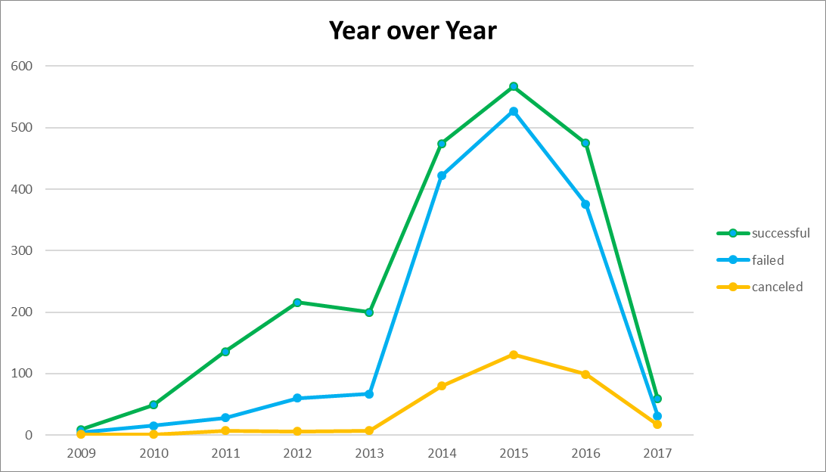

Another way we can analyze the data is by looking at the duration of campaigns on a 100% stacked column (Example B). This way we can see that even though campaigns that last 1-30 days and 31-60 days respectively account for 49% of all campaigns, the campaigns that last 61-90 days have a much higher success rate. Of course, further analysis would have to be performed to understand what the same distribution is by category and subcategory, but looking at this data in multiple ways helps us to start understanding what categories and durations return the most success.

Example B

